.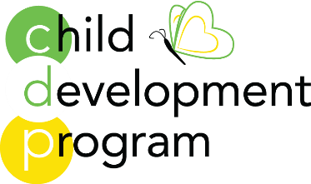

Toddler 1 and Toddler 2
2023-2024 Fee Schedule
Half Day Program 9am-12pm All fees are monthly
3 Day program ( M,W,F) $670
4 Day program (M-Th) $710
5 Day program $790
Full Day Program 9am -3pm
3 Day program (M,W,F) $800
4 Day program (M-TH) $850
5 Day program $890
All Day Program 9am – 5pm
3 Day program $910
4 Day program $935
5 Day program $980
All Day Program 7:45am – 5pm
3 Day program $940
4 Day program $975
5 Day program $990
Extended Care until 5:30pm (this is not a drop-in option you must be registered for the month)
Additional $35 monthly
Drop in fees Early Care $25(monthly $30) After Care $45(monthly $40) Half Day $50 Full Day $80
Sibling Discount $50

There is a nonrefundable registration fee $495
There are a limited number of need-based scholarships available.

