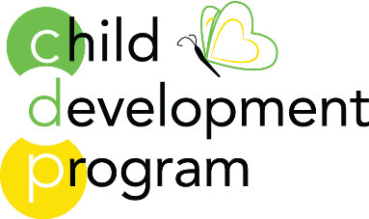
Little Lamb Program
2023-2024 Fee Sheet

Half Day Program 9am-12pm
3 Day program $700
4 Day program $760
5 Day program $825
Full Day Program 9am-3pm
3 Day program $830
4 Day program $867
5 Day program $887

All Day Program 7:45am – 5:30pm
3 Day program $944
4 Day program $1094
5 Day program $1150

Drop in fees Early Care $35 After Care $45
All Day $90 (for a day not already enrolled)
Sibling Discount $50
There is a nonrefundable registration fee $495

There are a limited number of need-based scholarships available.

